+ 1 DAY WT/34

TV COORDINATION REPORT

Event Title:
Location:
Date:
Prepared by:

Overall Assessment:

Pre-Event Communication
Execution of the Event in general
Venue
Audience
Music and
Stadium Announcer
Staff
Hotel
Transportation
TV Delegate received all necessary information
Other remarks

Production Coverage and Distribution

Communication with Production
Communication with HB
Standard of Directing
OB Van/Truck
Programme according to FIVB Running Order
Number of EVS
Individual use of EVS
Use of official FIVB Graphics
Remarks re Graphics
Position of Interviews
Who did the Interviews
Quality of Interviews
Opener & Closer used as agreed
Postcard(s)
Newsfeed according to requirements
Shotlist prepared
Match Schedule
Satellite Transmission
Award Ceremony
Re-Feeds
Challenge System
Video and audio recorded correctly on tapes/DVDs/HDDs
Recordings sent by courier service to RBMH by HB?
Recordings sent by courier service to FIVB by HB?
Other remarks

Camera Layout
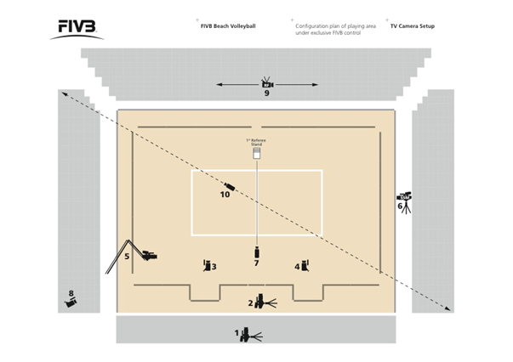
Correct camera positions
Additional cameras
Net camera
Height of camera positions
Use of individual cameras
Minimum number of cameras and as confirmed on WT/15 ?
Shadows

Audio Summary

Requirement | As per FIVB Guideline (Y/N) / Comments
Audio Configuration on the international Feed as agreed
Track 1 & 2 = International Sound (Music & effects)
Track 3 & 4 = International Sound Mix (inkl. Engl. Commentary)
Use of Audio Tracks 5 - 8
International sound clear and sharp + free of loud background noise
Commentator name
Standard of commentary
Instructions given to the commentators during the Live Production
Commentary box (Size, space, location, equipment)
Minimum number of microphones
Correct microphone positions

TV Meeting

Where
When
Attendances
Topics
Other Remarks

Host TV Broadcaster Summary

 | Y/N | Comments
Appendix E signed
WT/14 Form Submitted 60 days before event
WT/15 Form Submitted 60 days before event
Minimum Coverage

Broadcast schedule on Host Broadcaster’s Domestic TV channel

Match | Competition Day & Time | Broadcast Date & Time | Channel
Remarks
Live hours on HB channel

SNG & Times on Satellite

SNG
Engineer
Accessed Satellite
Comments
Feed # | Start of Broadcast | End of Broadcast | Approx needed  (Y/N) | Comments

Personnel On-Site

Organizing Committee
Host TV Broadcaster | Host TV Broadcaster:  Production:  Production Manager:  Director:
FIVB | Technical Supervisor:  Referee Delegate:  Press Delegate:
Other Broadcasters on-site

ENG crew Summary (if applicable)

ENG dates and schedule
Cameraman name and quality of work
Sound man name and quality of work
Camera format and tapes format provided

Additional

Remarks
Recommendations

Photos

