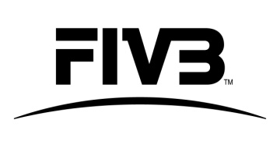 | ASSISTANT TECHNICAL DELEGATE  EVALUATION FORM  +7 DAYS

Event:
Date:
Assistant Technical Delegate:

Skill/ Quality/ Area of Expertise | Comments | Rating from 1-5 (1 being the lowest grade and 5 being the highest grade)
Competition and Sport:
Sport Regulations
Competition and Sport:
VIS

Competition and Sport:
Competition Schedule

Marketing:
knowledge of marketing / branding conditions

Marketing:
Understanding of necessity to verify the items

Marketing:
Experience in Marketing and Promotion

TV:
Knowledge of TV production and broadcast

Management skills:
Managing staff/team

Personal skills:
Organisational skills

Personal skills:
Communication skills

Personal skills:
Language skills

General Comments:

Recommendation to the FIVB to confirm/ not confirm the candidate as a Technical Delegate in 2017/2018:

Technical Delegate:
Signature:

