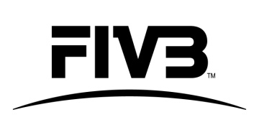 | TECHNICAL DELEGATE  EVALUATION FORM  +7 DAYS

Event:
Date:
Technical Delegate:

Please grade each of the quality/ skill of the Technical Delegate assigned at your event, 1 being the lowest grade and 5 being the highest grade.

 | Skills/ Knowledge | Mark (1-5) | Comment
1 | Previous experience at top level Beach Volleyball Events
2 | Knowledge of the Beach Volleyball Handbook, Sports Regulations, Rules of the Game, tools, etc.
3 | Communication skills
4 | Ability to explain rules/decisions, give advice and support the LOC
5 | Accepted and respected by LOC/Tournament Director/Promoter
6 | Accepted and respected by Players/Coaches/Media etc.
7 | Leadership of the FIVB officials group (i.e. FIVB delegates and other officials)
8 | Accuracy and reliability
9 | Problem Solving & Risk Management
10 | Knowledge of the VIS

Other Comments:

Host NF Representative:
Signature:

Promoter:
Signature:

