BY -35 days Team Entry

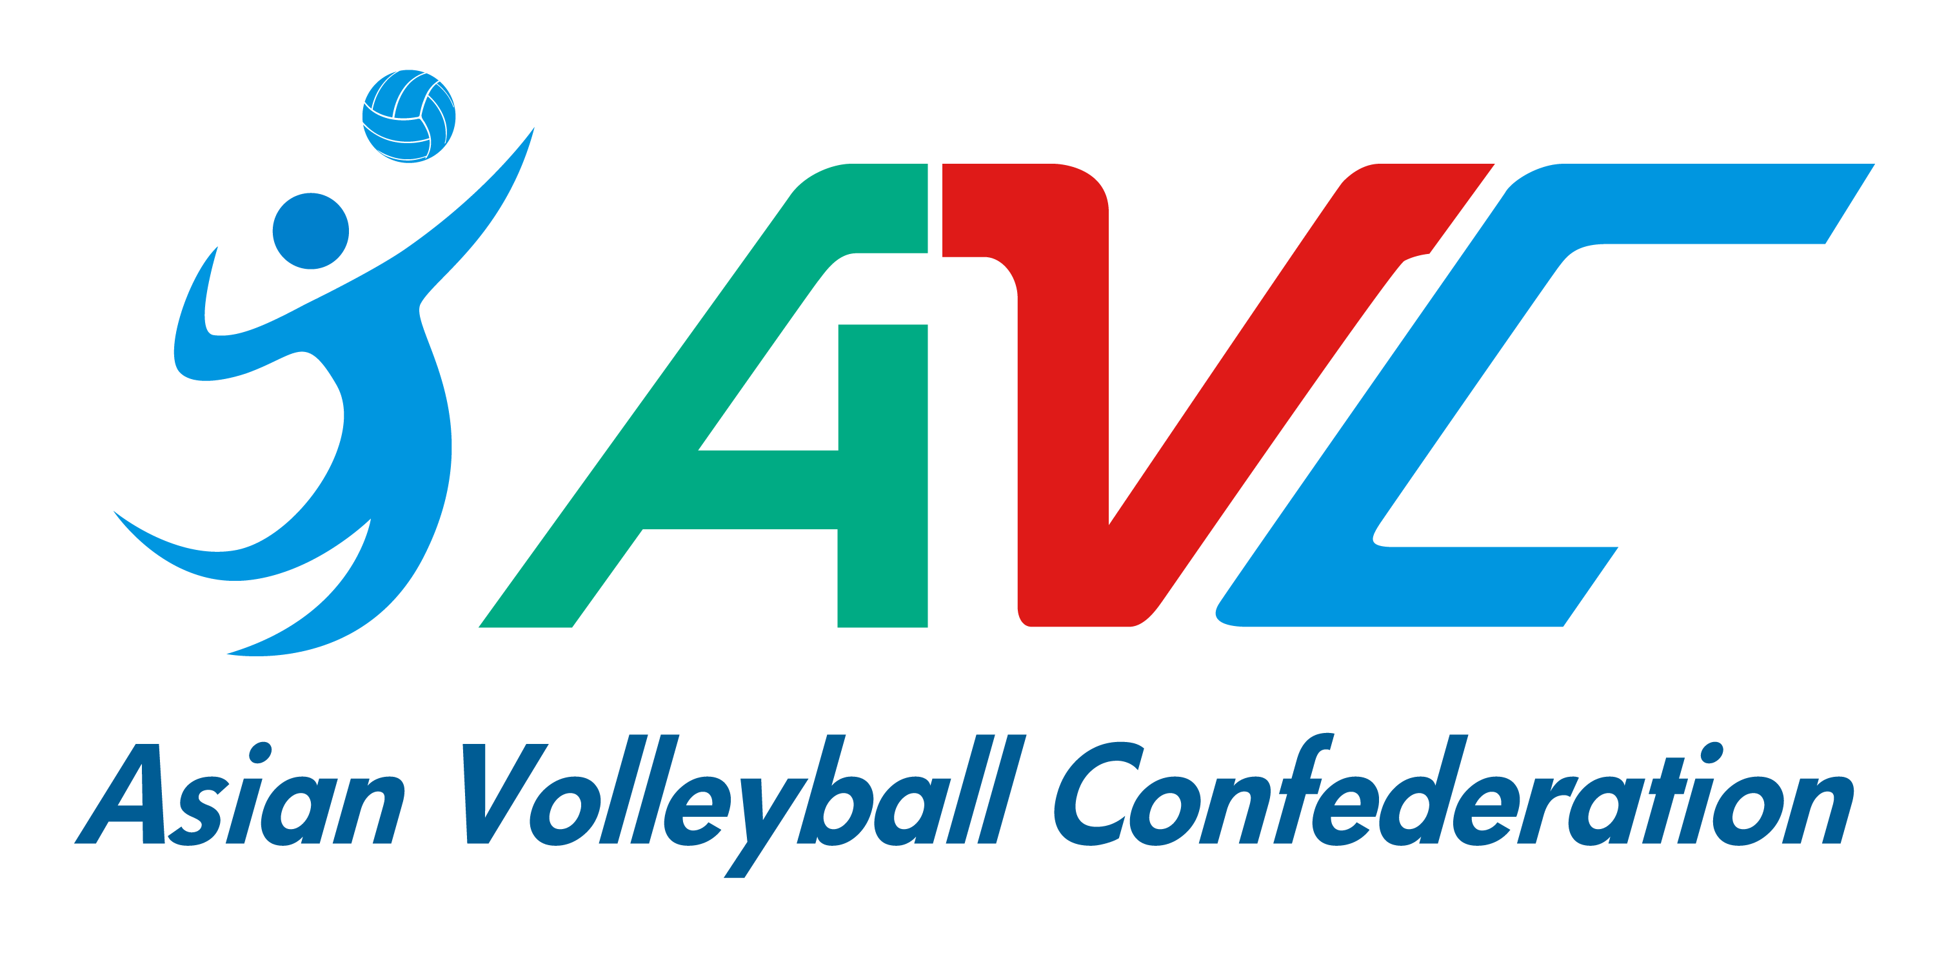
“Taichung Bank” AVC Beach Tour Penghu Open
August 17-20 Penghu, Chinese Taipei

This form must be sent to the organizer (and copy to AVC) by 13 July 2023 by email.
Each Federation can enroll two teams (2) teams plus one reserve team per gender. Host can enroll three (3) teams plus one reserve team per gender.

***IMPORTANT***
The National Federation must both submit the entry form and enter the below teams in the Volleyball Information System (VIS) www.fivb.org/vis as per the regulations.
Otherwise, the teams will not be eligible to participate in the event.
If the federations have any problems in register teams in VIS system, please contact
AVC Beach Department for further assistance.

WOMEN
TEAM | LAST NAME | FIRST NAME | FIVB ID # | SHIRT NO. | TEAM CAPTAIN | NF
1
2
3
(Host only)
Reserve

MEN
TEAM | LAST NAME | FIRST NAME | FIVB ID # | SHIRT NO. | TEAM CAPTAIN | NF
1
2
3
(Host only)
Reserve

Note: Team with the most points will be Team 1. If equals, depends on coach’s decision.
Note 2: If the Main Draw is not full (less than 24 team) The reserve team from Host and the reserve team(s) with the most entry points as of -35 days among all participating NFs’ reserve teams will be selected to fill the Main Draw.

TEAM OFFICIAL OR COACH & ACCOMPANYING REFEREE (IF ANY)

 | LAST NAME | FIRST NAME
TEAM OFFICIAL/COACH 1
TEAM OFFICIAL/COACH 2
ACCOMPANYING REFEREE
(Please inform shirt size for preparing referee uniform)

NATIONAL FEDERATION  AUTHORISED SIGNATURE | SEAL OF THE FEDERATION | PLACE AND DATE
……………………………………

