BY -35 days Team Entry

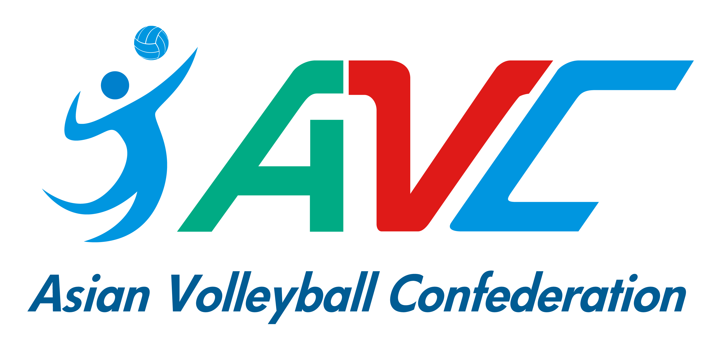
“Est Cola” 5th Asian U21 Beach Volleyball Championships
July 13-16 Roi-Et, Thailand
This form must be sent to the organizer (and copy to AVC) by 8 June 2023 by email.
Each Federation can enroll two teams (2) teams per gender. Host can enroll three (3) teams per gender.

***IMPORTANT***
The National Federation must both submit the entry form and enter the below teams in the Volleyball Information System (VIS) www.fivb.org/vis as per the regulations.
Otherwise, the teams will not be eligible to participate in the event.
If the federations have any problems in register teams in VIS system, please contact
AVC Beach Department for further assistance.

WOMEN
TEAM | LAST NAME | FIRST NAME | FIVB ID # | SHIRT NO. | TEAM CAPTAIN | NF
1
2
3
(Host only)

MEN
TEAM | LAST NAME | FIRST NAME | FIVB ID # | SHIRT NO. | TEAM CAPTAIN | NF
1
2
3
(Host only)

Note: Team with the most points will be Team 1. If equals, depends on coach’s decision.

TEAM OFFICIAL OR COACH & ACCOMPANYING REFEREE (IF ANY)

 | LAST NAME | FIRST NAME
TEAM OFFICIAL/COACH 1
TEAM OFFICIAL/COACH 2
ACCOMPANYING REFEREE
(Please inform shirt size for preparing referee uniform)

NATIONAL FEDERATION  AUTHORISED SIGNATURE | SEAL OF THE FEDERATION | PLACE AND DATE
……………………………………

